David Beauchamp
Poker Database Project Write Up
Code (database design, processing, and sql queries) will be included in an SQL file and Jupyter Notebook in my Github Repository.
{Link to be included on Sunday prior to submission.}
The following Database Schema, Diagram and Design were all written and created by me. AI was used to clarify concepts, debug errors, and review design decisions and more granularly focused on pre-processing PHHS files (See Jupyter Notebook).
Conceptual Diagram/Schema {Example Schema – Reproduce after DB Creation}
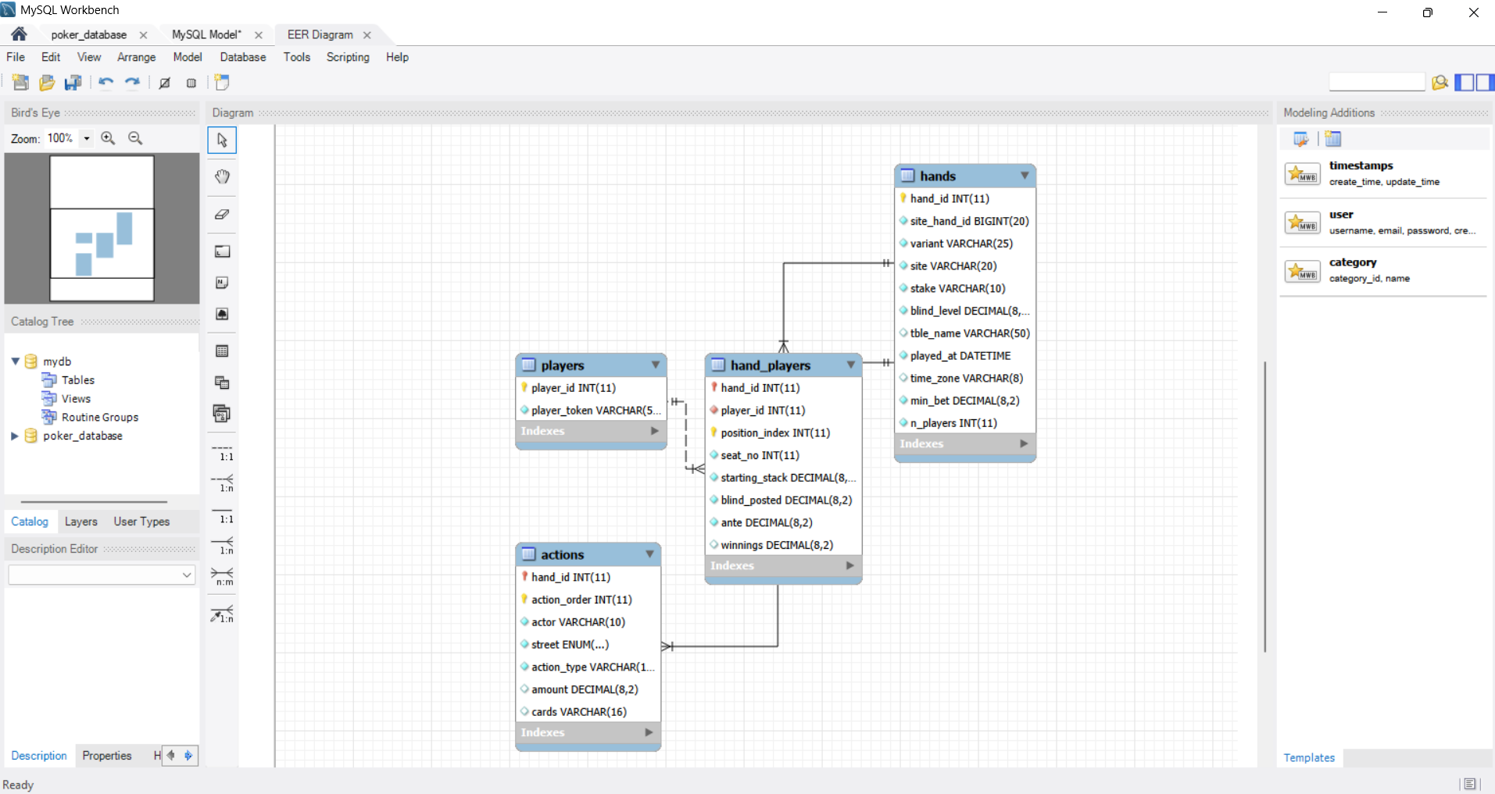
Diagram Structure Explained:
I’m building a reproducible database schema and design for poker preprocessing, storage and analysis. For my conceptual schema, you’ll see it consists of four tables.
The Hands table is our central entity, followed by players as our lookup table. Hand_players is our many-to-many bridge since one player has many hands, and one hand contains many players. The Actions table is designed as our one-to-many (1:M) detail table holding the event sequence of each hand and also maps which players made which actions.
Our players table is designed as our look up table as it contains our player_tokens (as a unique
key) from each site. It’s also containing an auto-incremented player_id as our primary key to distinguish between players across our database.
Our hands table has a primary key in hand_id, autoincremented and set up by the system since we’re processing data across sites. It also has many different attributes with varying data types that support date-time, variable character length, integers and non-null values in specific places.
Entity Descriptions & Database Constraints:
Players: The first table is the Players table, which will contain a player_id, an Int, in our Database, auto incremented, so its created as our unique primary key for each player across websites. I also chose VARCHAR(50) for our player_token, derived from our data, in case different websites have varying character lengths. This player_token is the site’s (venue) unique ID for each player. We mark this as unique, not null as it’s required for play.
Hands: For the second table, hands, we’ve created a new hand_id column as our primary key, auto incremented by the system so we have unique IDs across sites. Then we have our site_hand_id, an integer; our site, which maps to the Venue field; and more details of the hand such as blind level, which is expressed in decimals (same as min bet, .05 for instance). The Variant should be all NL games but I’m unsure that each site/stake has ‘NT', it could just as easily be written long-hand, No-Limit-Texas-Hold’em thus I’ve put longer constraints. N_players we’ve added as a count to see how many players are in the hand. We also have time_zone expressed as ‘est’ in example, played_at expressed as a datetime object, table name and stake level. Finally we’ve created a unique key combination for site & the site hand ID so that if one site has a hand ID of 10, and another site has that same ID, they’re still considered separate hands!
Hand_players: Our bridge table containing our two foreign keys in hand_id and player_id. From the sample size I gathered the hand IDs weren’t very long so I kept it to 20 characters, variable size across sites (potentially). Position index is the order within the PHH array, shown in the Juypter Notebook, index i+1 of players, starting_stacks and winnings. It’s a file format coordinate, the seat number is the physical charat the table from the seats array in our dataset. Seats can be empty charts and don’t start at 1. (Dealer actions do not appear here but in the Actions table). The rest of the data points are all decimals, starting stack, blind posted, ante and winnings. There could be another consideration to add losses or allowing winnings to be negative indicating ‘signed’ but for now we’re just assessing earnings, not losses. I also made it so the default value of ante, winnings and blind posted is zero.
Lastly, I created an index named idx_player on the player ID column to improve performance of joins and queries on player_id.
I also created two foreign key constraints: fk_hp_player which references player_id in the players table and fk_hp_hand which references the hand_id in the hands table. These constraints keep referential integrity by ensuring both player_id and hand_id in this table already exist in their respective parent tables.
Actions Table: This is where the Dealer lives and is why actor is a plain VARCHAR so it can hold ‘dealer’ alongside the players (p1, p2, etc). I decided not to make actor as a foreign key to hand_players because it would have forced us to create a fake dealer row or split deal events into a separate table. I have hand_id as my foreign key so we look at actions across each hand.
I created action_order so we could determine whether ‘cc’ is a check or call to parse out that info. If the ‘cc’ is before any ‘cbr’ then it’s a check, if there’s a ‘cbr’ in our action order and then ‘cc’ that indicates a call. This is parsed out and explained more in our Jupyter Notebook. Actor is where we delliniate between who made what action and getting dealer actions as well. Street is breaking up each street of action between dealer actions so it can only contain one value from the enum(list). The street column must contain one of the four values ‘preflop’, ‘flop’, ‘turn’, ‘river’ with NOT NULL as a distinction. The cards column is designed for the board cards in each hand that’s also NULLable since players can realistically fold before any cards are dealt.
Furthermore, I created a composite primary key for this table made up of components hand_id and action_order because every hand_id and every action_order should be unique. Every poker hand has several actions and the action_order tells us the sequence of those actions within the hand. I also created the index idx_street_type comprised of the street/action type to make queries/look ups easier for instead Where Street = ‘Turn’ AND action_type = ‘cbr’ will be able to utilize this index efficiently.
Lastly, my foreign key constraint fk_hand, referencing the hand_id column in the hands table rounds out the table.
Assumptions/design decisions:
As highlighted in the Jupyter Notebook available in my Github repository, the public data contains obfuscated hole cards making it impossible to analyze hand strength unless retro-actively fit to cards exposed at showdown. Instead, we’ll focus on action-based analysis.
Another consideration I made is a surrogate hand_id and player_id since the “venue” or website/application has it’s own unique ID which could match with another sites and cause false positive duplicate issues. +
It states Venue in our data but since it’s all online data, I adjusted the term to ‘site’ for clarity/integrity of data.
We also created ‘amount’ as NULLable since fold actions won’t have any amount tied to them.
I also separated our ‘cc’ variable for check/call during parsing since it’ll have a severely positive effect on analysis. While a Check is a passive action, it’s not meant to affect VPIP since you’re not voluntarily putting money in the pot. This is parsed out in the Jupyter Notebook.
Date/Time was also cobbled together from several fields (time, day, month, year) into one for concise storage and easier analysis (and made into a date-time object) as this is going to be key when there’s a time component in our analysis, IE weekend vs weekday play or changes over time.
I decided to parse out different streets, as I felt I needed to in order to do any meaningful analysis, and the ‘cc’ (not cbr since they’re all aggressive actions) so we can determine VPIP and PFR. A V2 would include player position, button, under the gun, cutoff, etc so we could look at VPIP/PFR by position (as theory indicates adjustments depending on how many players are yet to act).
Lastly, there’s 21 million hands with multiple actions per hand so we’ll be using a sample data size of 500 files/roughly 500k hands each. We’re also going to limit down the stakes we’re analyzing to 50NLH, 200NLH and 1000NLH so we can simplify and showcase the biggest analytical differences across player pools.
PS: When importing my data I ran into a few errors, one being Infinite designations instead of null. Upon research using Claude AI, I found the site’s exports sometime don’t record stack sizes, so PHH authors encoded unknown as infinity. We’re converting these to NULL since the true value is unknown. We’ve created a ‘Clean’ function that makes it none/null instead of infinity so we can move forward and thus I adjusted my Non NULL values to NULLable values for starting_stack, blind_posted, ante and winnings since some players might not have any value.
Database Queries:
First, you’ll see all Database/Table code within the SQL file. The Inserts of data will be in the Juypter Notebook via Python’s my-sql-connector library since we have parsing that we handled with the data before inserting into our database.
The initial queries are looking at the sample dataset we entered which pulled back nearly 2000 hands, across 132 players, 10,725 seats (roughly 5 seats per hand), 28k actions across 2000 hands all the data being from 1000NLH, one of the strongest fundamentally. This provides a great baseline for us to run some initial analysis and queries.
I took the VPIP/PFR of all 1000NL Hold’em which is an extremely strong representation of how players play at that stake level. The mean value is very strong theoritcally and will allow us to work backwards when importing more hands across stakes to finish our analysis on the other stakes and hopefully see some differences. We can drill down to different streets and sequences of actions, for instance looking at Monotone boards, rainbow boards or just by street.
My second query is exactly Query 1 plus stake, grouped by player/stake. We’re computing per player rates first then the average per stake but the output is exactly what we’re looking to accomplish in our application.
